**Docker Web Server Deployment Guide Using AWS**

Table of Contents  
  
• Prerequisites

• AWS EC2 Instance Setup

• Security Configuration

• EC2 Instance Connection

• System Preparation

• Docker Installation

• Project Deployment

• Monitoring and Logging

**Prerequisites**

**Required Tools**

* AWS Account with appropriate permissions
* SSH client (Terminal on Mac/Linux, PuTTY on Windows)
* Text editor (VS Code recommended)
* Docker Engine (Docker and Docker-Compose)

**Required AWS Permissions**

* EC2 Full Access
* VPC management permissions
* Security Group management
* Elastic IP allocation (optional)

**AWS EC2 Instance Setup**

**Step 1: Launch EC2 Instance**

1. **Navigate to EC2 Console**
   * Log into AWS Management Console
   * Navigate to EC2 service
   * Click "Launch Instance"

**Instance Configuration**

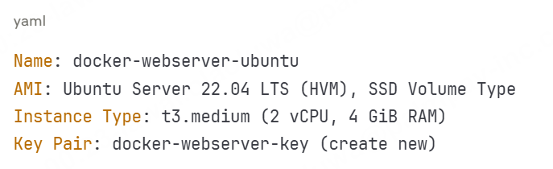

**Network settings**

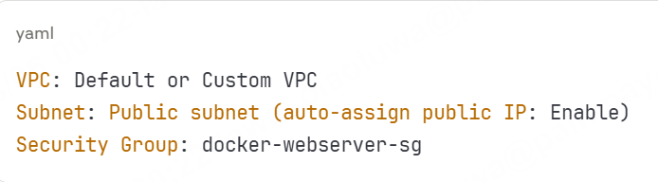

**Storage Configuration**

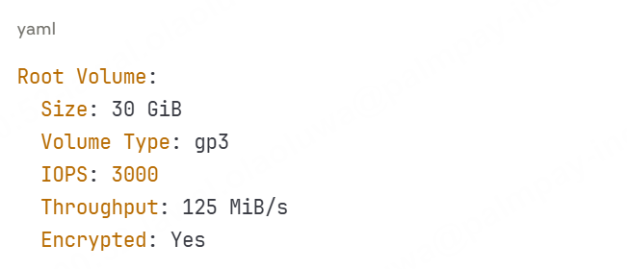

**Security Group Rules**

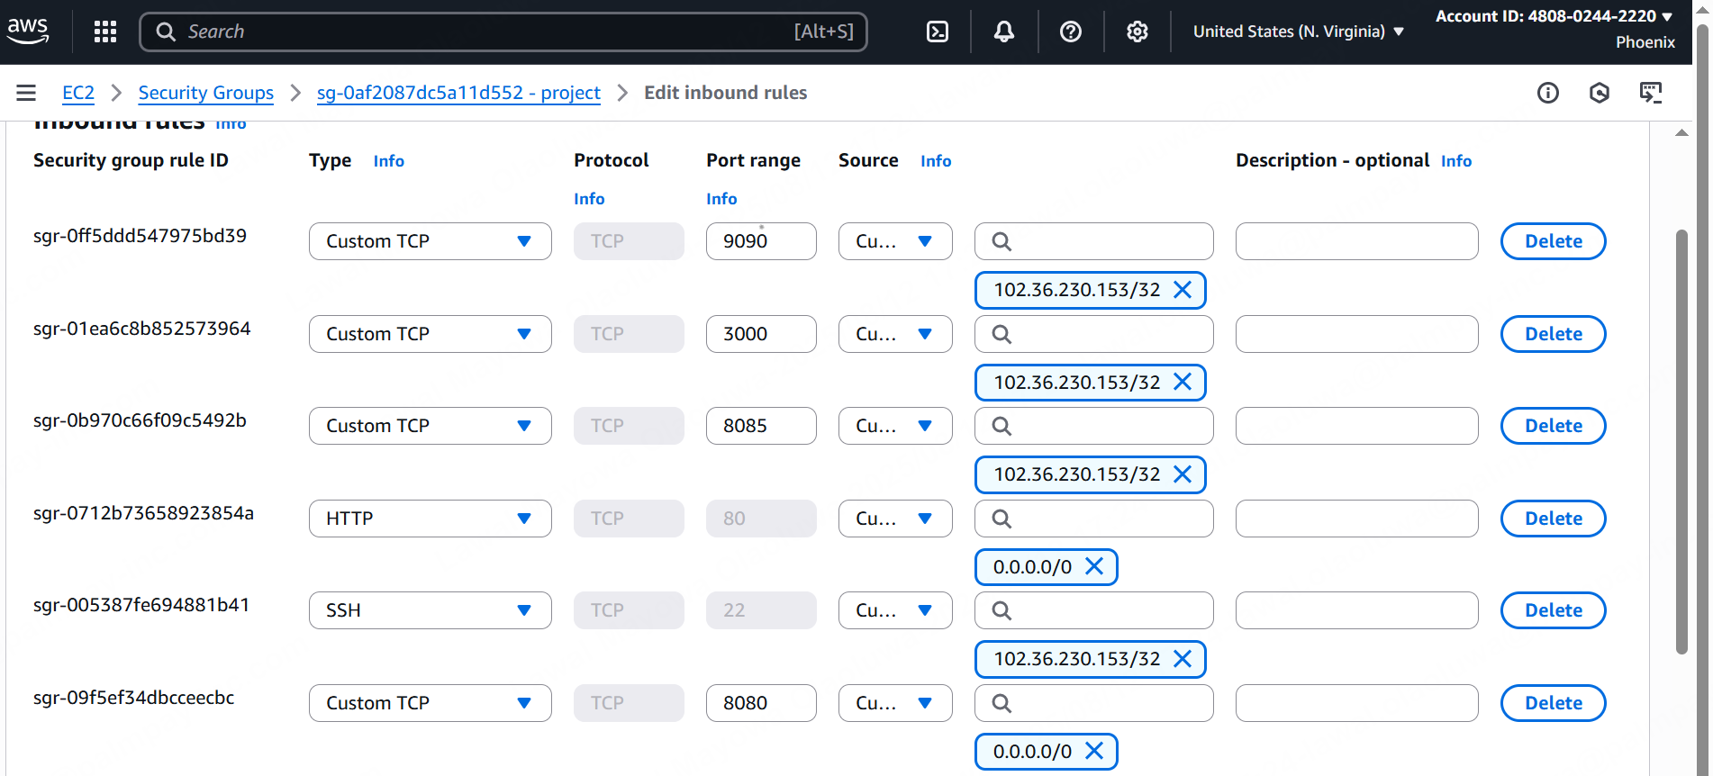

**Security Configuration**

Key Pair Security:

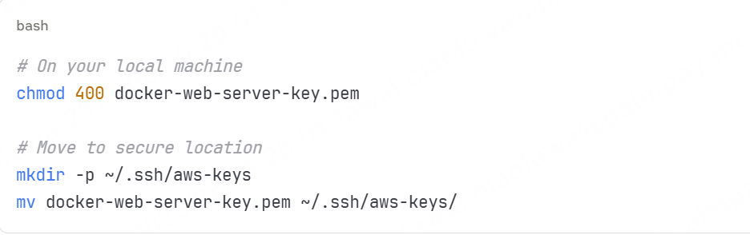

Connect to Instance:

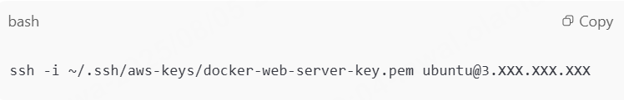

Alternative with DNS Name

ssh -i ~/.ssh/aws-keys/docker-web-server-key.pem ubuntu@ec2-3-XXX-XXX-XXX.region.compute.amazonaws.com

Initial Connection Verification:

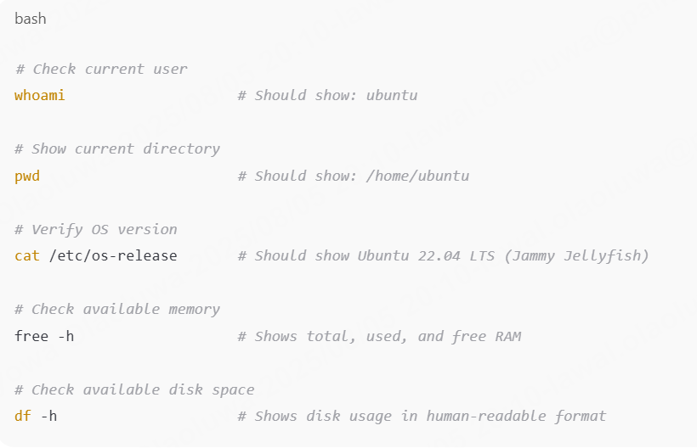

**Connect to Ubuntu Instance**

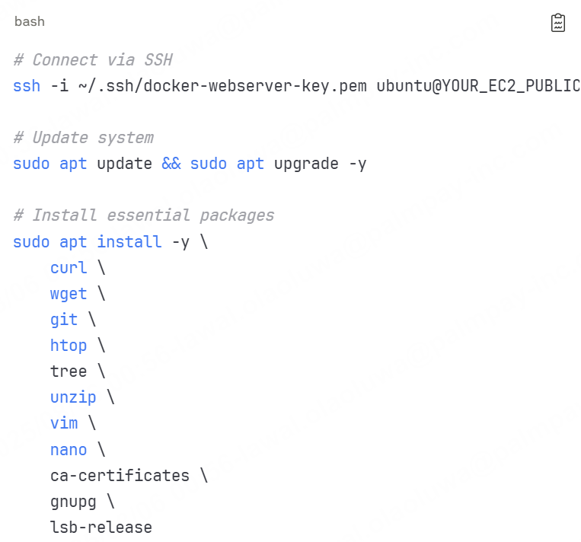

**Docker Installation & Configuration**

**Install Docker Engine**

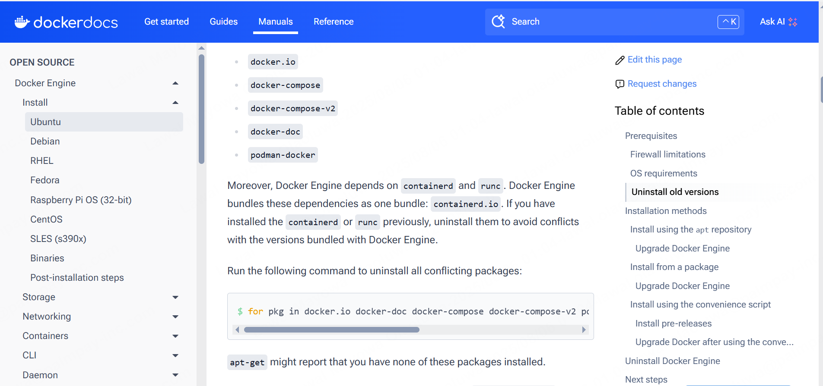

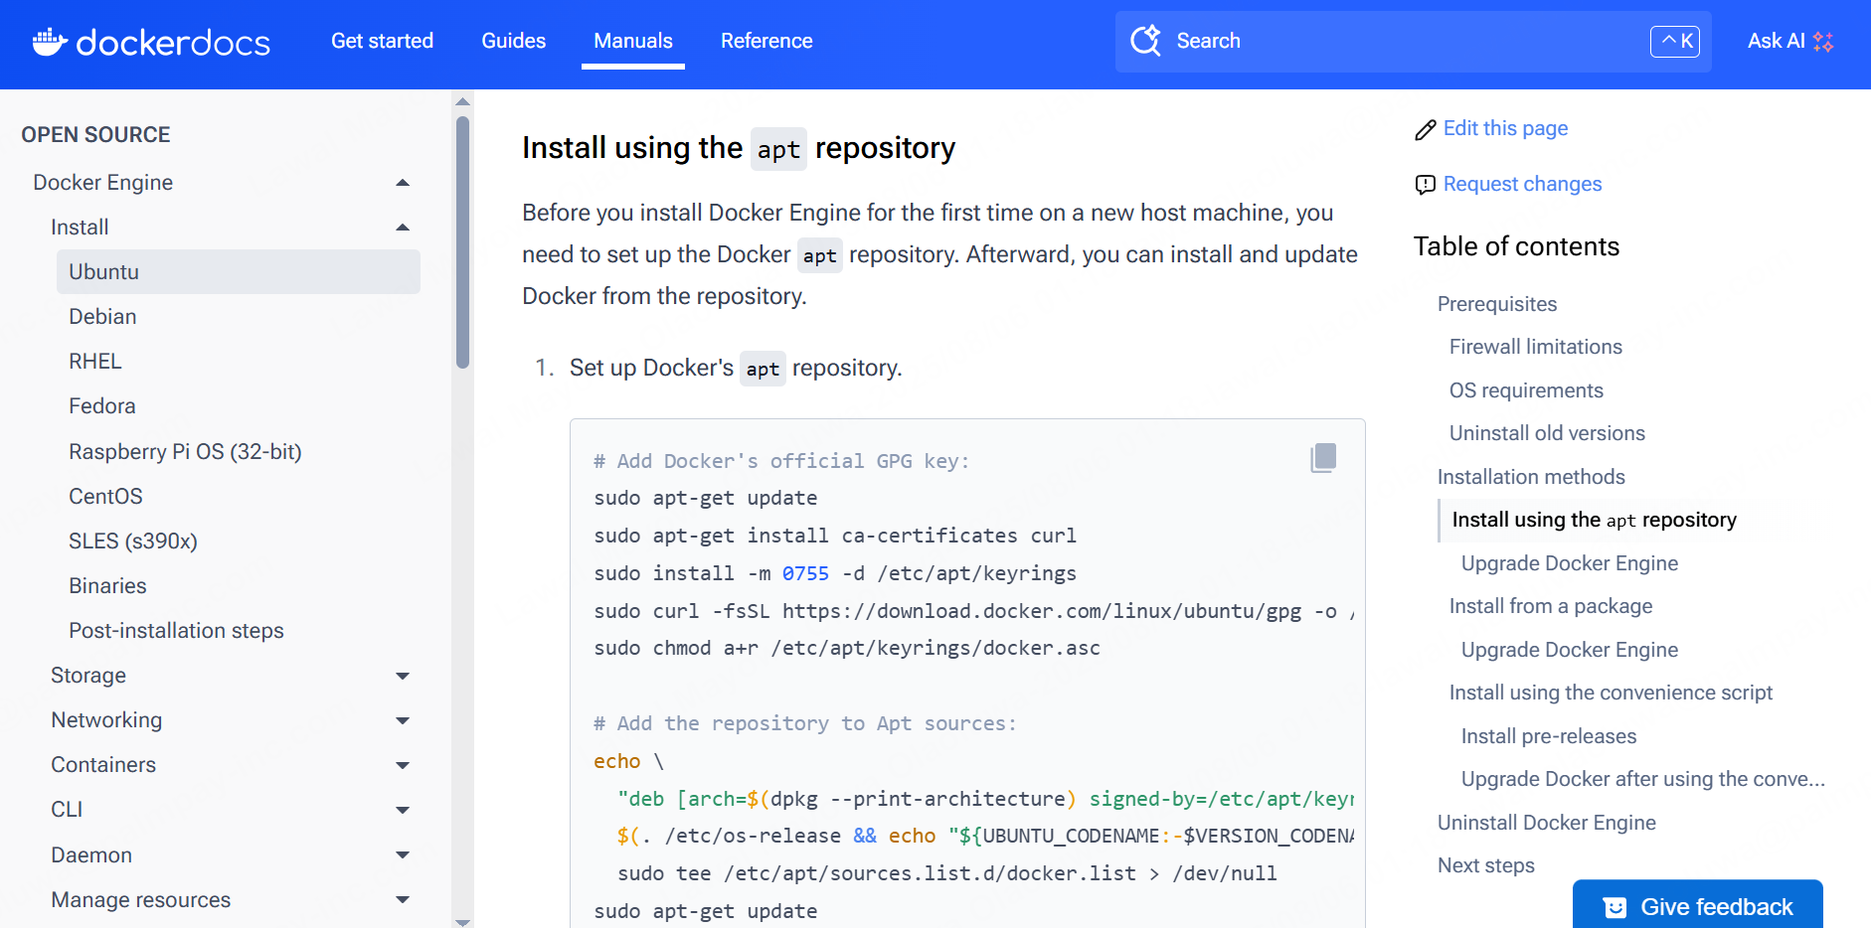

**Configure Docker**

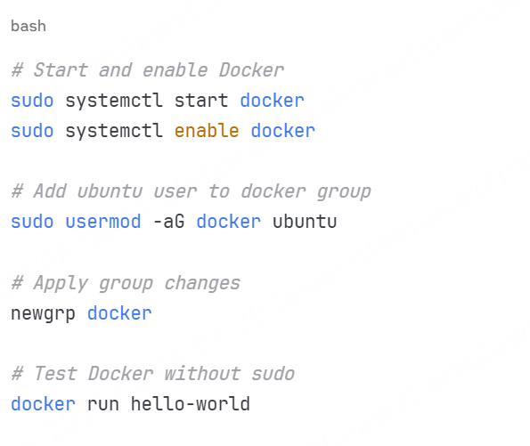

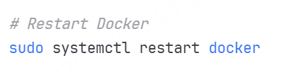

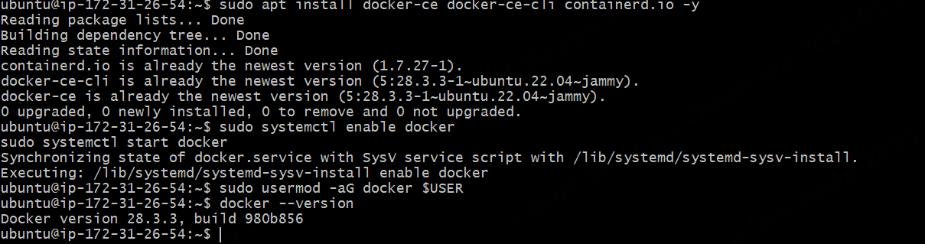

**Download docker-compose.**

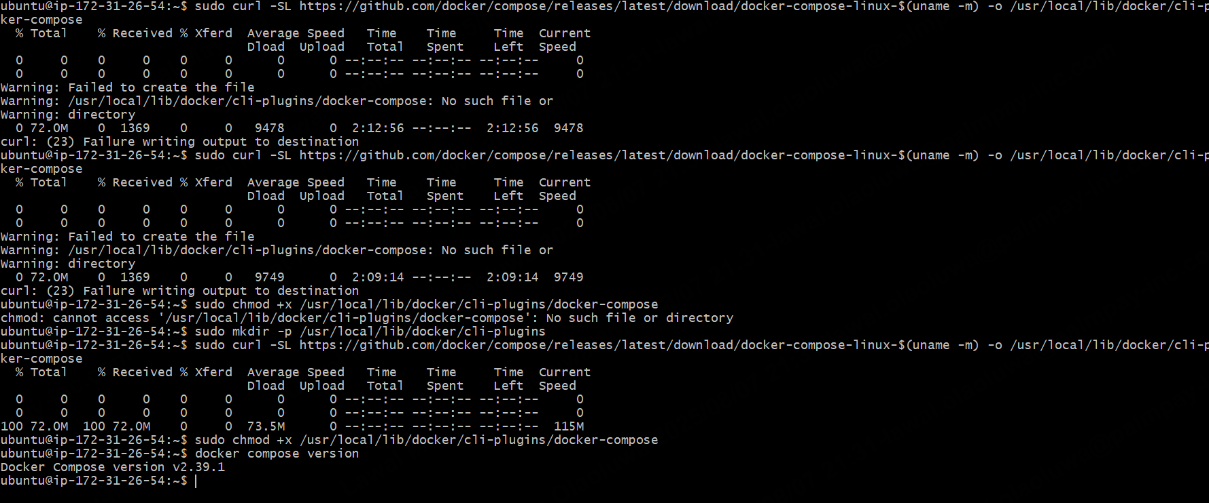

**Project Deployment**

**Create a folder “dockerproject”**



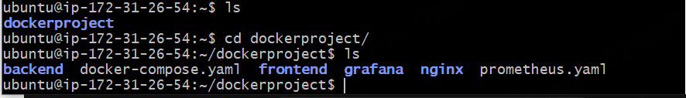

**backend folder:**

* **Dockerfile** - Container build instructions specifically for the backend service, **package.json and** **server.js**, dependencies installation, and server startup commands

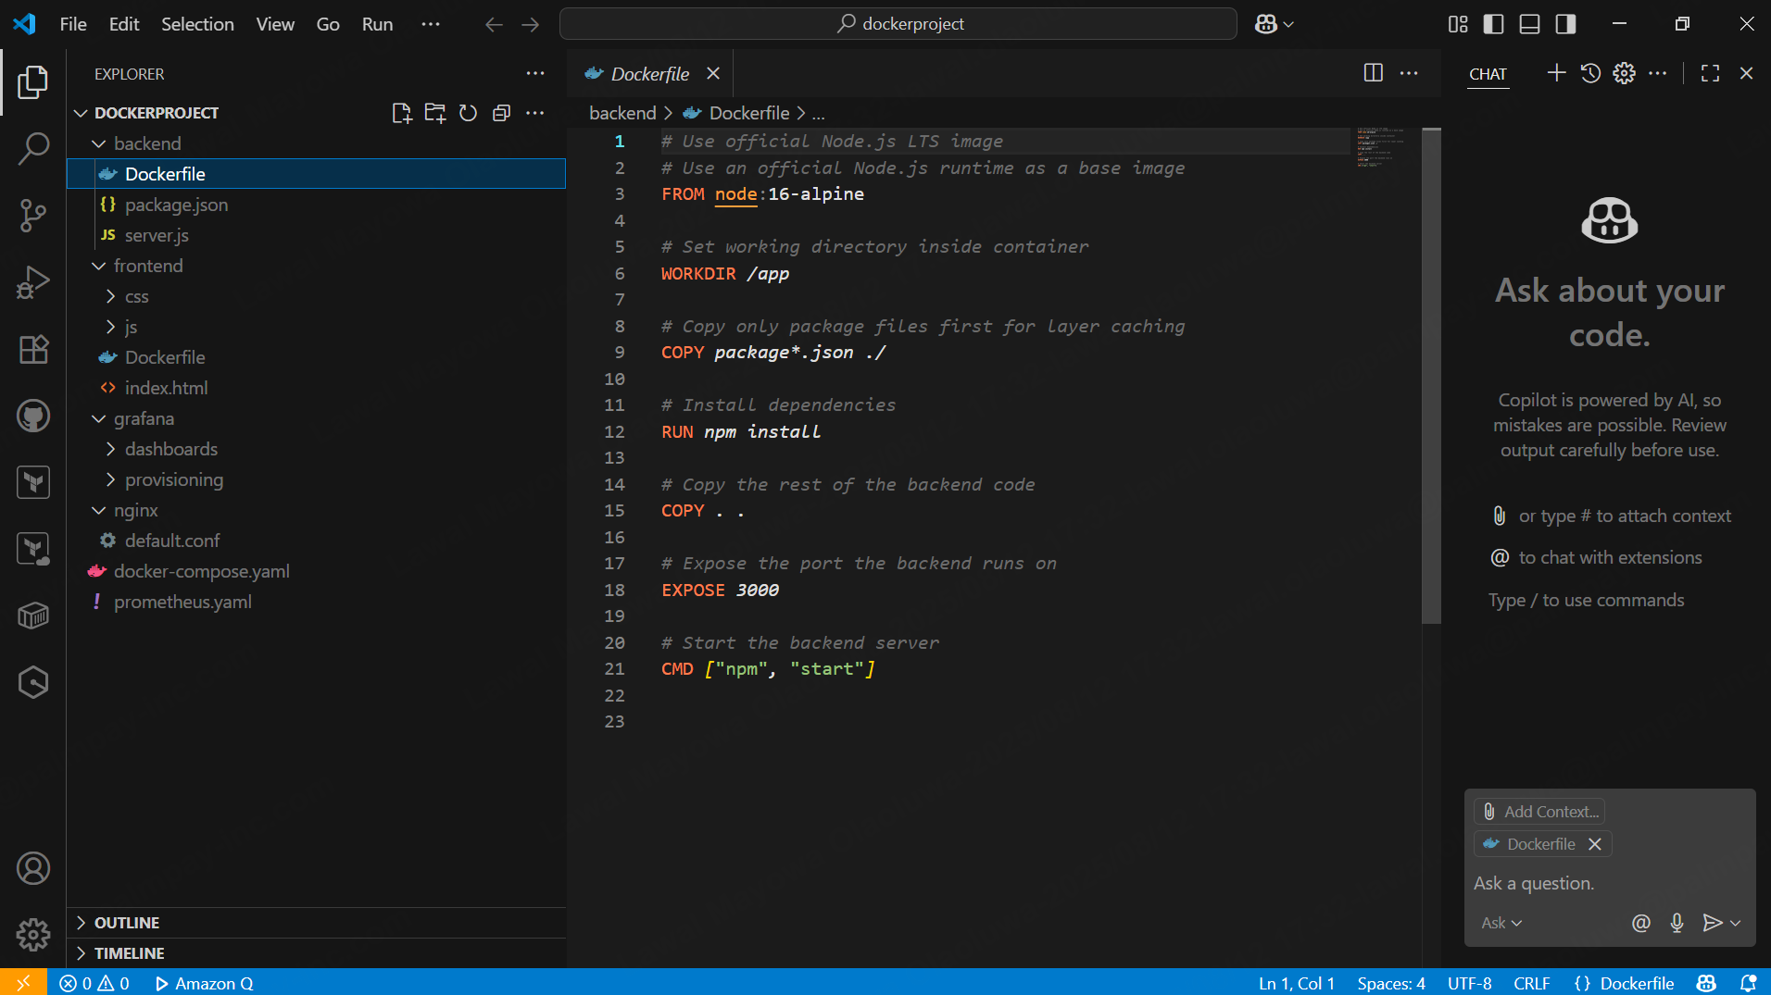

* **package.json** - Node.js project configuration containing backend dependencies, scripts, and metadata for the server-side application
* **server.js** - Main backend application entry point, an Express.js server handling API routes, database connections, and business logic

**Note: Backend was pushed to docker hub, and later mention in the docker compose file.**

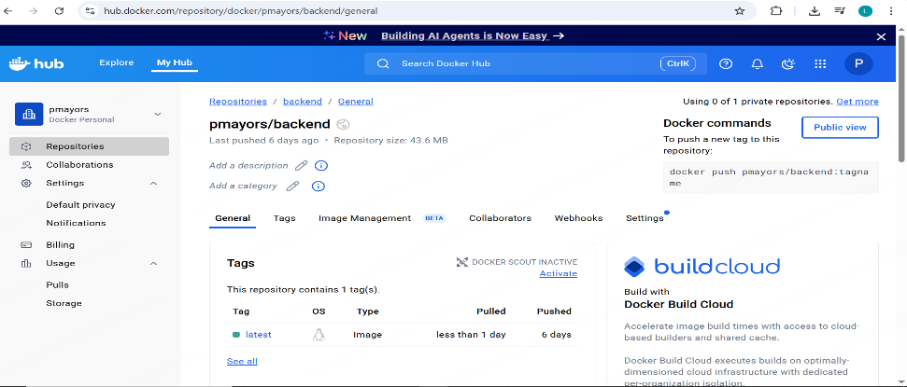

**frontend folder:**

* **css** - Contains stylesheet files for frontend styling, layout, and visual presentation of the web interface
* **js** - JavaScript files handling frontend functionality, user interactions, API calls, and dynamic content manipulation
* **Dockerfile** - Container build instructions for frontend service, setting up a web server (nginx/apache) to serve static files  
  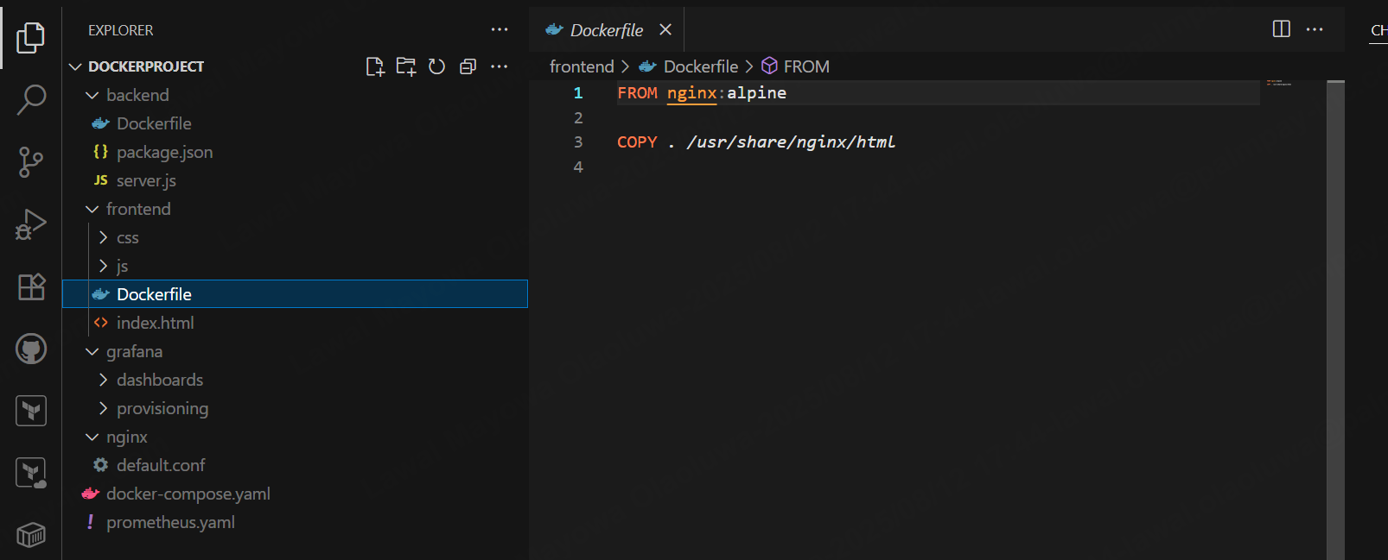
* **index.html** - Main HTML entry point for the web application, containing the base structure and references to CSS/JS files

**grafana folder:**

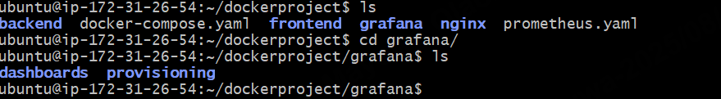

* **dashboards** - Pre-configured JSON dashboard templates for monitoring metrics, visualizing data, and creating custom monitoring views
* **provisioning** - Configuration files for automatically setting up datasources, dashboards, and other Grafana components on container startup

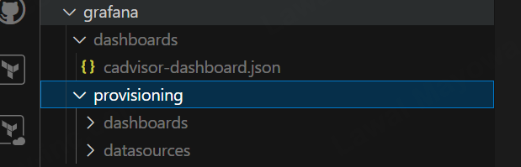

**Web Server**

**nginx folder:**

* **default.conf** - Reverse proxy configuration defining routing rules, upstream services, load balancing, and request forwarding between frontend/backend

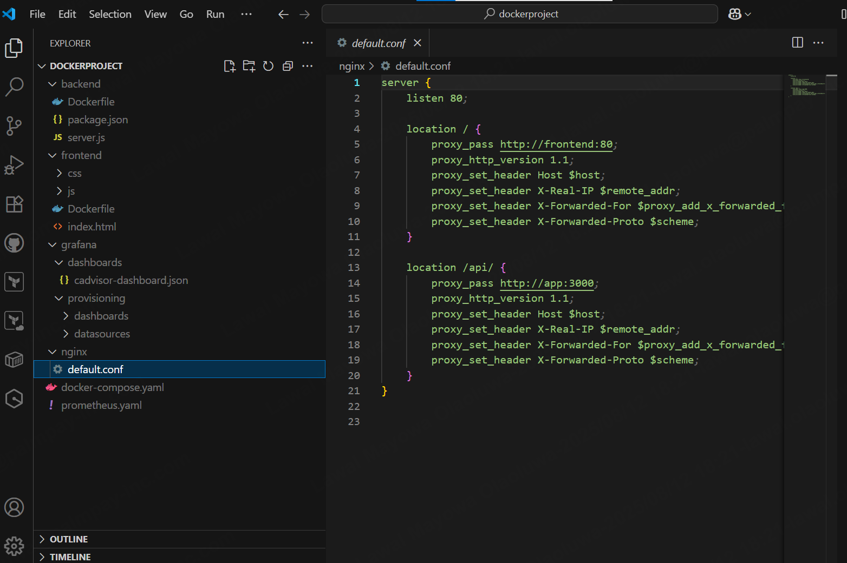

**Configuration files:**

* **docker-compose.yaml** - Multi-container orchestration file defining services, networks, volumes, and dependencies for the entire application stack

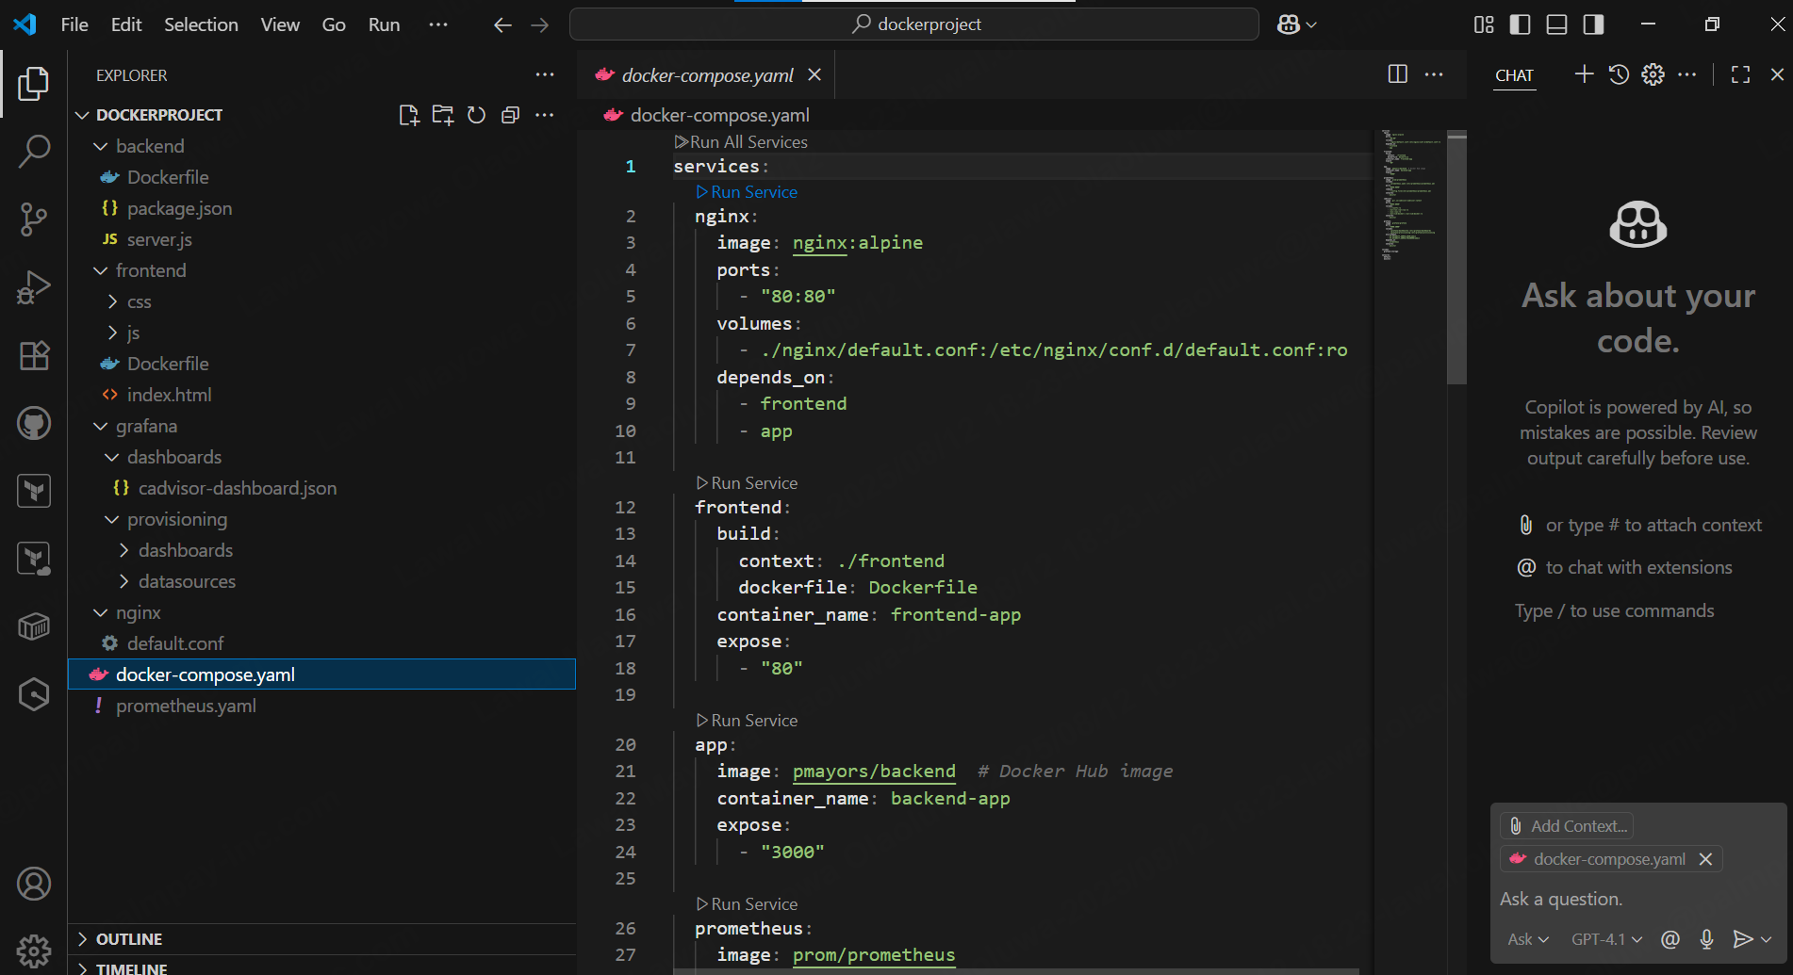

* **prometheus.yml** - Monitoring configuration specifying scrape targets, intervals, and rules for collecting metrics from various services

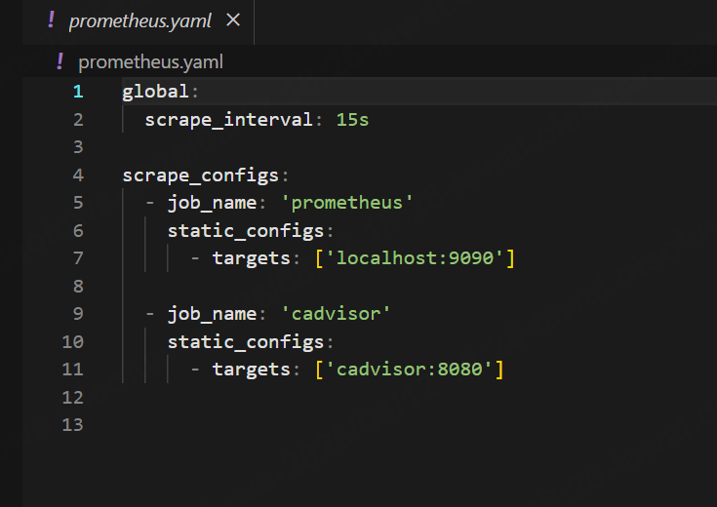

This is a comprehensive microservices architecture with separate frontend/backend services, monitoring stack, and reverse proxy setup.

**Launching**

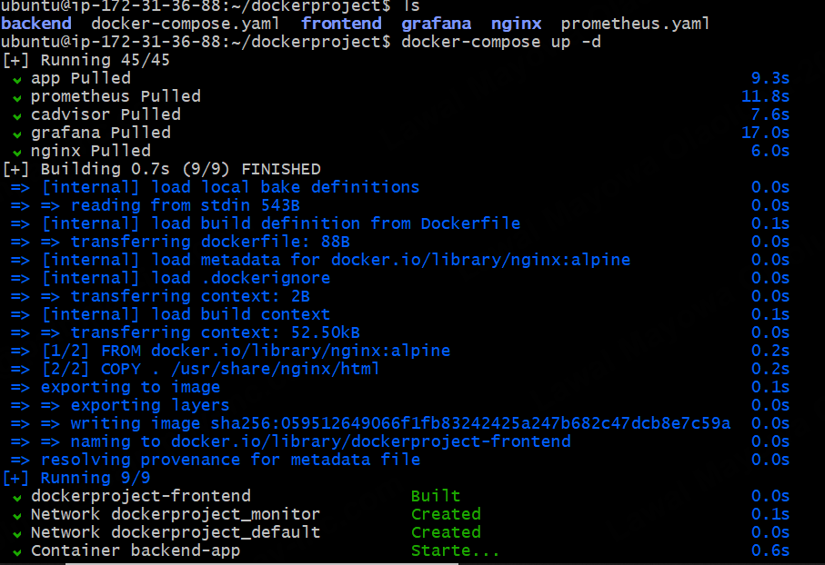

Docker compose up -d

for a Docker multi-service project with **backend, frontend, Grafana, Nginx, Prometheus**, etc.

* **Images** for services (prometheus, app, grafana, nginx) were pulled or built locally.
* The **frontend** image was built from a Dockerfile using nginx:alpine.
* Docker created two networks (dockerproject_monitor and dockerproject_default) for service communication.
* The backend-app container was started successfully in detached mode.

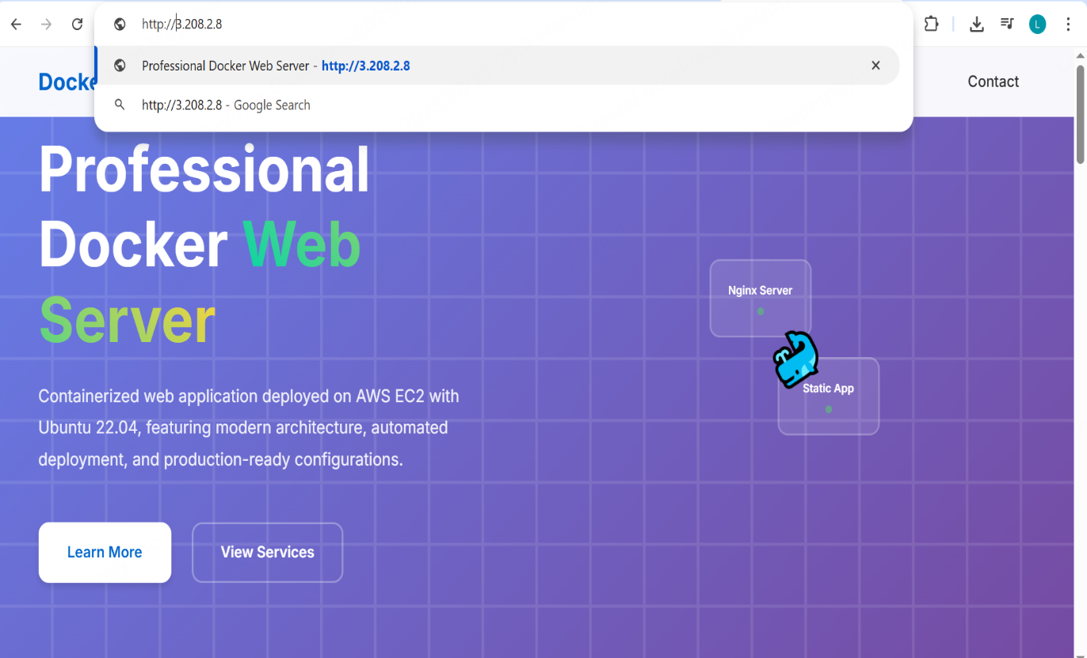

Check with the IP of your instance.

**Steps for monitoring and Visualization steps**.

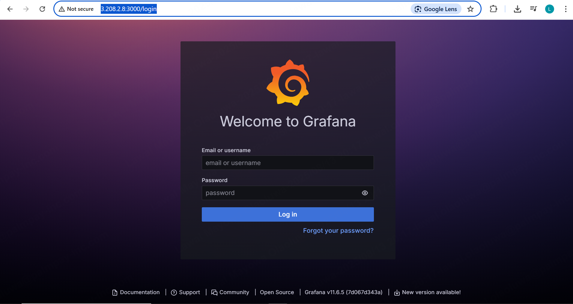

Login to Grafana with <http://yourIpaddress:3000>

Username: admin Password: admin.

Click on **Import Dashboards**

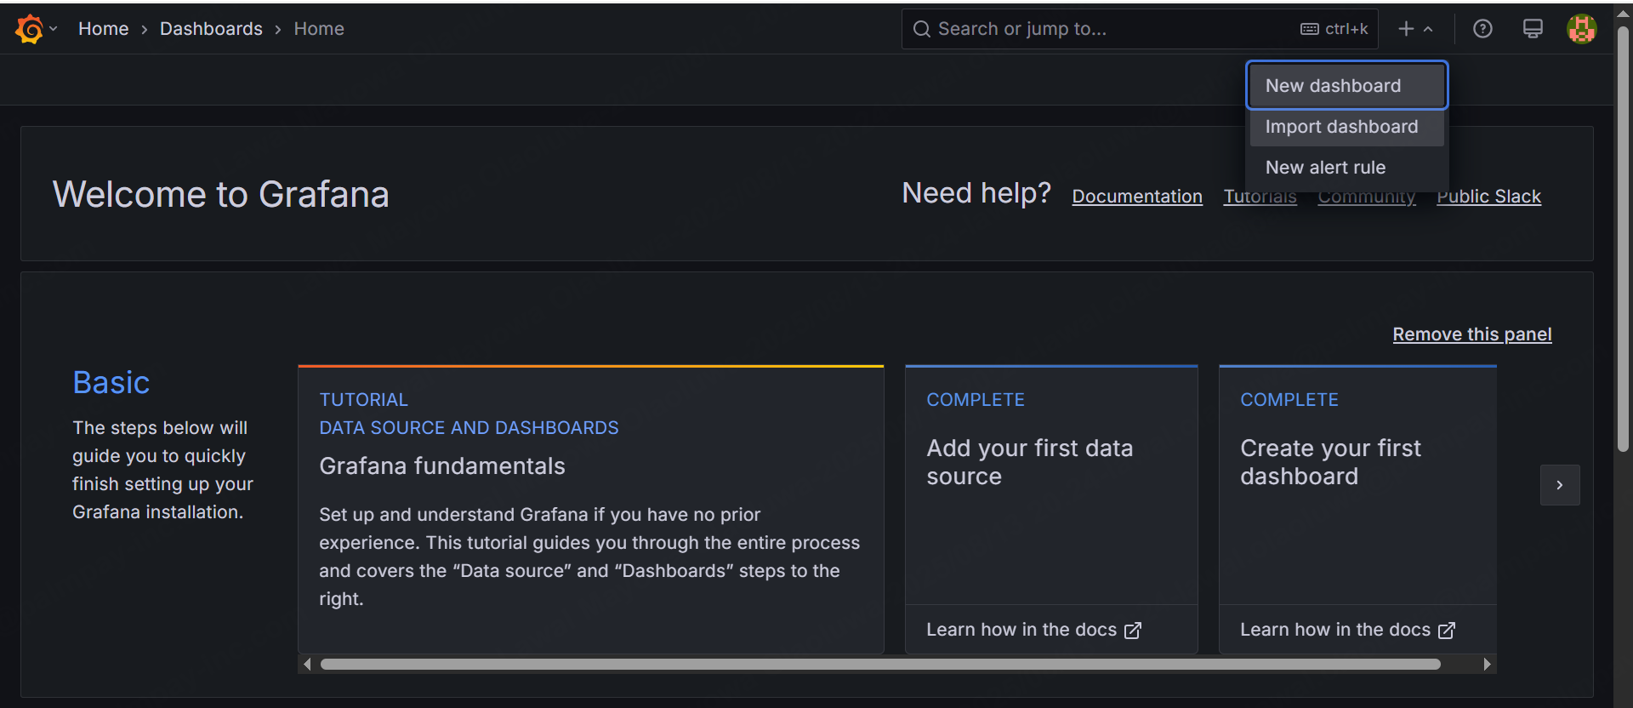

**Imput 193 and click load**

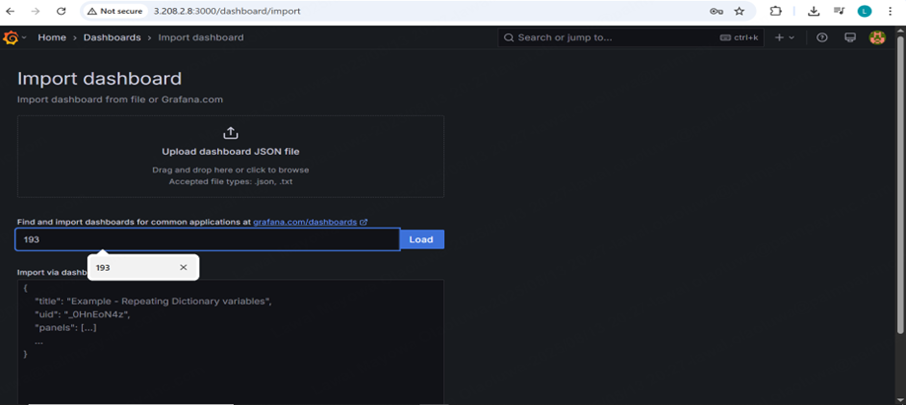

**Click Prometheus and import to see the dashboard**

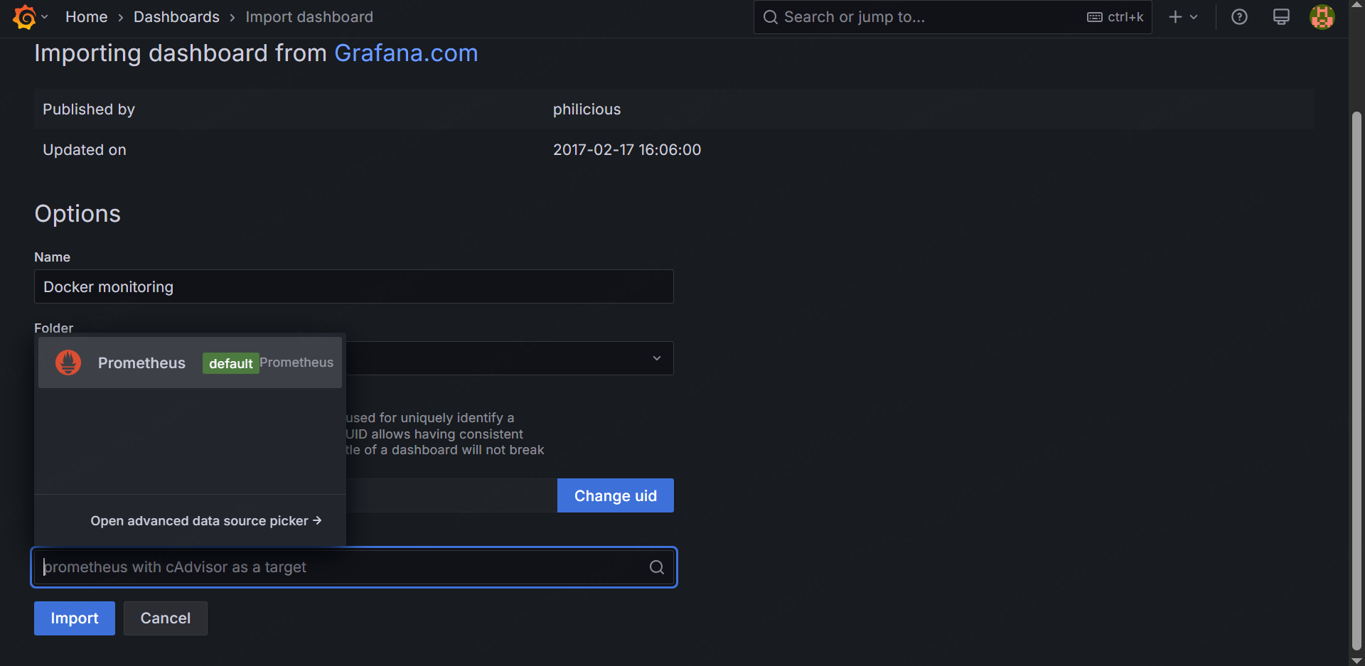

**Grafana Dashboard**



